Response analysis of a parked spar-type wind turbine under different environmental conditions and blade pitch mechanism fault
ABSTRACT
Offshore floating wind turbines are subjected to harsh environmental conditions and fault scenarios. The load cases considering parked and fault conditions are important for the design of wind turbines and are defined in the IEC61400-3 and other design standards. Limited research has been carried out considering fault conditions so far. For a parked wind turbine, the blades are usually feathered and put parallel to the wind direction during survival conditions to minimize the aerodynamic load. However, if the pitch mechanism fails, the blades cannot be feathered to the maximum pitch set point―the blades are seized. The accidental seizure of the blade will likely cause a large drag loading and increase the extreme responses. For a floating turbine, the consequences could be quite severe. The uneven wind loads together with the wave loads can jeopardize the dynamic responses such as yaw, pitch and the tower bending moment. The degree of impact depends on the environmental conditions as well as the position of the turbine blades. Wind turbines are supposed to be designed for survival of environmental events with a return period of 50 years as well as certain combined fault and environmental conditions with an equivalent occurrence rate. However, the probability of fault scenarios is not well known. Hence, this study is based on parked turbines and conditions on the 1-year environmental contour line for a site in the North Sea, as well as a study of the sensitivity to the environmental conditions around the 1-year condition. Two parked scenarios are considered: one with faulted seizure of the blade and one without. The turbine’s steady responses to the wave direction and blade azimuth position are investigated. A spar-type wind turbine is used in this study. It is found that most of the responses are sensitive to the wave direction. For the normal parked conditions, the yaw and roll responses of the platform are sensitive to the blade azimuth while the sway, surge and pitch are not. For the parked conditions with fault, the blade azimuth position plays a key role in the roll, yaw and sway responses. The fault cases result in larger extreme and mean values of the responses such as tower bottom shear force and moment. The response spectrum and the standard deviation vary from case to case due to the interplay of hydrodynamic and aerodynamic loads. Under the 1-year environmental conditions considered, the fault cases generally have a 20% increase of the maximum tower bottom bending moment and out-of-plane blade bending moment compared with the normal parked cases. The fault cases under 1-year environmental condition are also compared with the normal parked ones with an environmental condition corresponding to 50-year recurrence period.

INTRODUCTION
Offshore wind energy has witnessed rapid development in recent years. The total installed capacity in 2010 reached approximately 3000 MW, some 1.5% of worldwide wind farm capacity[1]. Development has mainly taken place in North European countries, mostly around the North Sea and the Baltic Sea, where to date a few more than 20 projects have been implemented[2]. In the design of offshore wind turbines, a set of design conditions and load cases with a relevant probability of occurrence shall be considered. The load cases, which are used to verify the structural integrity of an offshore wind turbine, should include normal, fault and transportation design situations with various external conditions[3, 4]. Despite the need for defining a possible fault case, the correlation between a likely environmental condition and a fault situation remain virtually unknown for a land-based turbine, let alone an offshore one. Therefore, it is necessary to assume appropriate environmental conditions corresponding to the specified fault scenario in the design case analysis.

The occurrence of the faults and the severity of the end-effects are important for offshore wind turbines. The former can be quantified based on the statistics about the failures experienced by wind farms[5, 6]. The end-effects, namely the potential harm inflicted on the wind turbines, are the main topic of this paper. Based on the field database of 450 onshore wind farms, it was shown in the recent RELIAWIND project [7, 8] that the pitch system failure contribute 21.29% to the total failure rate. Among the various forms of pitch actuator faults, valve blockage is safety critical and leads to an inoperable pitch actuator and thus a fixed blade[9]. Upon the presence of such severe fault, the protection system, designed by a fail-safe philosophy, is activated to ensure immediate shutdown[10]. The rotor is brought to a standing still or idling state by brakes. For an offshore floating wind turbine (FWT) with the fault mentioned, the outcome is largely decided by the wave and the wind that it is subjected to for a certain period of time.

Simulation of floating wind turbines considering parked and fault conditions have been limited so far. Bir et al. found that certain parked (idling) conditions can lead to instabilities involving side-to-side motion of the tower and yawing of the platform for a barge-type wind turbine[11]. Jonkman[12] and Matha[13] also documented platform yaw instability when they considered the blade pitch fault with an idling rotor. The instability may be caused by a coupling of the barge-yaw motion with the azimuthal motion of the blade. Madjid et al.[14] compared two non-operational cases for a standing still spar-type wind turbine under harsh environment and observed extra nacelle surge for the case with yaw fault. Generally speaking, when a floating wind turbine rotor is brought to a complete rest, the aerodynamic excitation and damping are sensitive to the blade azimuth angle and angle of attack relative to the inflow wind. Azimuth angle are associated with load distribution due to wind shear and geometrical symmetry. Angle of attack impacts the lift, drag and damping. Pitch or yaw mechanism fault may affect the angle of attack directly and spread the effect to the hydrodynamic loads that are sensitive to the platform motion. Thus, it would be interesting to investigate to which degree the fault condition may worsen the responses compared with the normal parked condition and which response of interest is significantly affected, especially under harsh environmental conditions.

In this paper, the aerodynamic damping of a stationary blade under normal and fault condition is first presented. A catenary moored deep spar floating wind turbine is selected and steady state responses of the parked turbine are performed using HAWC2[15]. Nonlinear mooring line forces are fed to HAWC2 at each time step through the dynamic link library. Aerodynamic loads are calculated from a look-up table of lift and drag coefficient corresponding to certain angle of attack. Hydrodynamic forces are calculated based on Morison equation considering instantaneous position of the platform. Validation of the hydrodynamics of HAWC2 can be found in[16, 17].

Environmental conditions with 1-yr and 50-yr recurrence period are chosen from the environmental contour line due to the lack of knowledge of fault situation and extreme external conditions. This may be on the conservative side. The effect of blade azimuth angle, and wave direction on the responses is investigated. The fault cases under 1-yr extreme environmental condition are compared with the normal parked cases with an environmental condition corresponding to 50-year recurrence period. Some light is shed on how the pitch mechanism fault may affect the dynamic responses of the floating wind turbine selected.

THEORY
Parked and fault scenario
It is possible to actively adjust the pitch angle of the entire blade on a pitch regulated wind turbine[18]. By doing so, the angles of attack along the blade length can be simultaneously changed to control the power output during operation. The pitch mechanism is a hydraulic system consisting of pump station, accumulator, valves and hydraulic actuators. The position of the piston and the blade pitch angle is determined by applied hydraulic pressure (Fig.). When the turbine is normally parked and prevented from idling, the blades are usually feathered and stay parallel to the incoming wind direction at azimuth angle γ (Fig.). However, valve blockage or pump blockage can disable the pitch actuator and brings it to a locked position [9]. The related blade is seized and the turbine shut down to prevent further damage. In this paper, the faulted blade is assumed to be seized at the pitch point of 0 degree, see fig.

Aerodynamic load

For a given blade section, the angle of attack is subjected to constant change due to the unsteady oncoming wind flow and the motion of the blade itself. So is the lift and drag force. For simplicity, we ignore the torsional motion of the blade and consider a typical section as illustrated in Fig. The blade section is assumed to have one translational degree of freedom described by θ. W₀ is the relative velocity which takes into account the inflow wind and the rigid body motion of the blade, φ₀ is the steady state inflow angle and α_{W} is the steady-state angle of attack. The quasi-steady aerodynamic forces per unit length can be written as
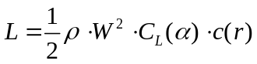
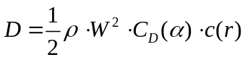
Where ρ is the air density, C_{L} and C_{D} are the lift and drag coefficients, c(r) is the cord length at a given radius and W is the relative speed. For a parked wind turbine, the blades are non-rotating and the induction factor is approximately 0. At each time step, the HAWC2 code calculates the angle of attack on each blade section, computes the loads and the response based on a multi-body formulation. For a feathered blade parallel to the oncoming wind, the aerodynamic load is dominated by lift. (Fig.) For a seized blade, the load is drag-dominated. Due to the motion of the blade and the turbulent nature of the wind, there exists lift force too (Fig.) .
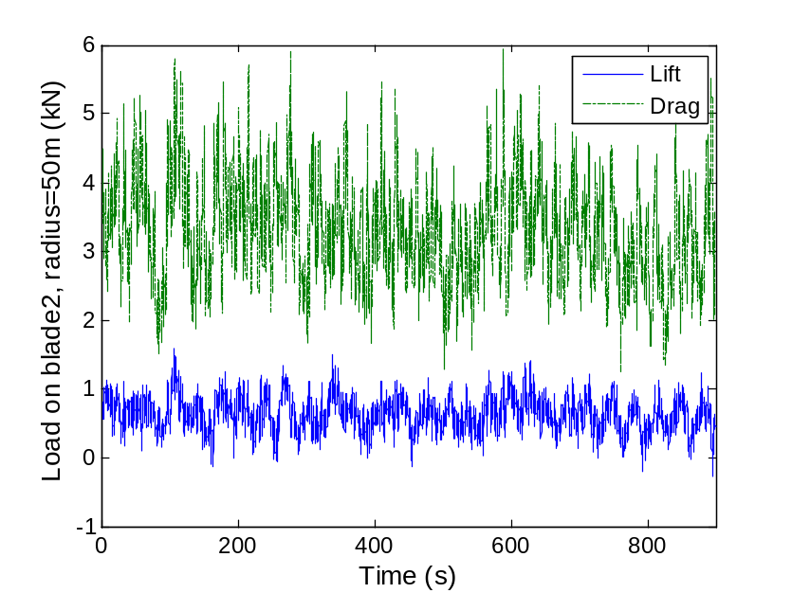
Time history of aerodynamic loads on a seized blade, V=38.7m/s, I=0.12, Hs=12m, Tp=14.2s

At a time instant, the relative velocity and the angle of attack of the blade considering its unidirectional vibration can be expressed as
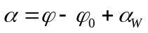
Where is the blade vibration velocity, α is the angle of attack. The aerodynamic forces, if projected onto the direction of vibration η, lead to[19]
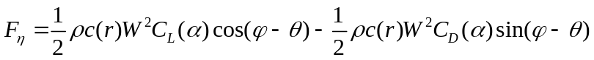
F_{η} can be expanded by Taylor series about 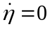
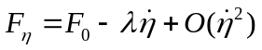
Where F₀ is the mean excitation force and the first mode damping coefficient in –η direction is given by[19]
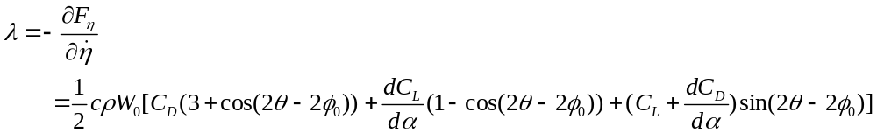
The aerodynamic damping coefficient is proportional to the relative inflow speed and is sensitive to inflow direction. Negative aerodynamic damping would result in instability if the structural damping is insufficient to dissipate the absorbed energy during vibration. This NACA 64 airfoil is applied in this study. Take the average angle of attack at radius 45m. It varies from -13 to +5 degree for a feathered blade and from 79 to 86 degree for a seized blade under the environmental conditions considered. Fig. and Fig. show that the linear aerodynamic damping coefficient for a seized blade is much higher than that of a feathered blade. The coefficient reaches its maximum in the flapwise direction (+90 and -90 deg), the direction close to the inflow wind. The damping coefficient of a feathered blade stays more sensitive to the steady-state angle of attack and reaches the maximum around the blade edgewise direction. The aerodynamic damping stays positive in the investigated cases. Besides, the blade structural damping is limiting the blade tip deflections. Therefore, the airfoil is less subjected to aeroelastic instability[1, 19, 20] under the environment considered.
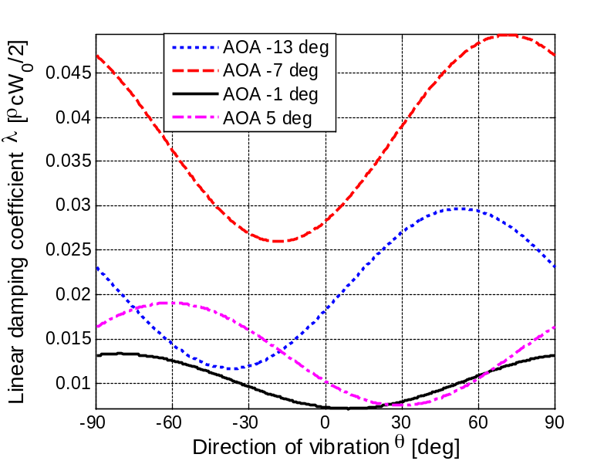

Aerodynamic damping coefficient of a feathered blade
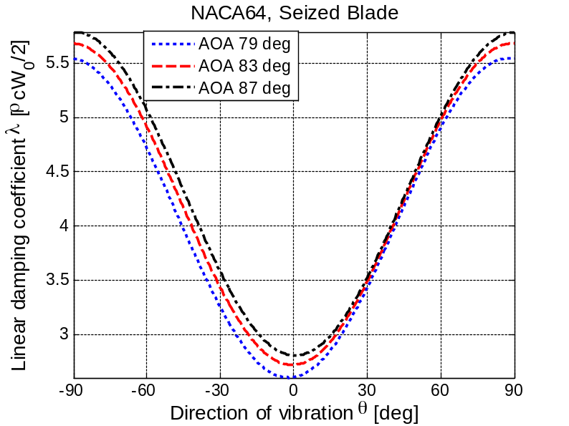
Aerodynamic damping coefficient of a seized blade
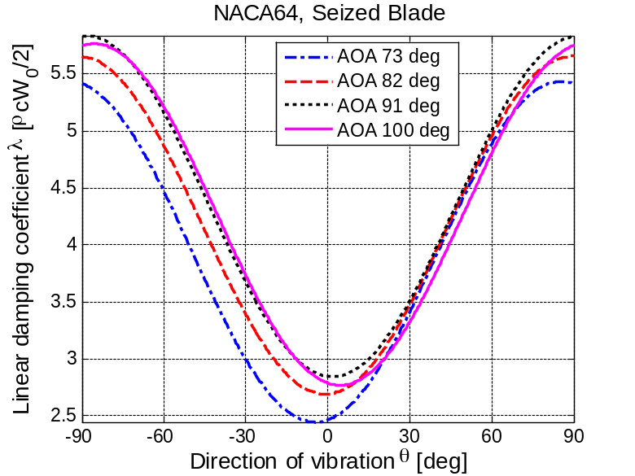
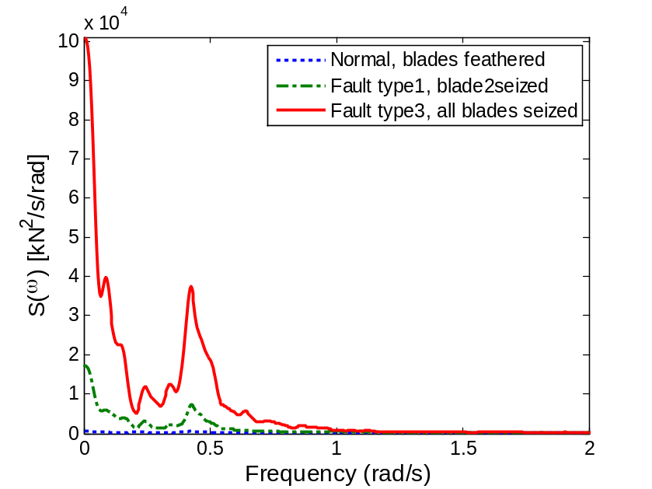
Thrust Spectrum, blade azimuth 0, V=38.7m/s, Hs=12m, Tp=14.2s
Since the bulk of the wind energy is concentrated below 1 Hz[20] and the flapwise natural frequency of the blade is calculated as 0.64 Hz, significant resonance can be induced in -y direction (Fig.) for a seized blade and in –x direction for a feathered blade. Due to the increased drag brought by the seized blade, the thrust force increases significantly (Fig). The thrust, dominated by components with frequency less than 1 rad/s, contributes to the platform responses such as surge and pitch.

Hydrodynamic load
Since the spar-type supporting platform is of circular cylinder shape and the ratio of wave length over cylinder diameter is large, the wave loads in HAWC2 are calculated by the Morison’s formula which accounts for the instantaneous position of the structure. The Morison’s formula consists of mass force and drag force and the horizontal force on a strip of length dz can be written as[21]
Where ρ is the mass density of the water, η₁ is the horizontal motion of the strip, u and a₁ are the horizontal undisturbed fluid velocity and acceleration evaluated at the center of the strip. C_{M} and C_{D} are the mass and drag coefficients. Dot stands for time derivative.
It is worth mentioning that the empirical mass and drag coefficients are dependent on the Reynolds number, the Keulegan-Carpenter number and the surface roughness of the cylinder. For deep water and the chosen coefficients, the wave loads are dominated by inertia loading (Fig.) and decay with depth exponentially[21]. Fig. and Fig., illustrated that the wave loading at the upper part of the spar platform contributes more to the total force. The second term in eq. indicates that the dominating inertia force is sensitive to the acceleration of the platform motion. Due to the presence of the aerodynamic drag load in –y direction, the fault cases with one or three blades seized were associated with larger thrusts. The heavier thrust loads in the tower top led to more pronounced platform motion. The water depth being small near the free surface zone, the hydrodynamic loading was dominated by the first term in Eq. That is to say, regardless of the blade pitch position and the wind loading magnitude, the wave force kept the same level (Fig). As the water depth increases, the first term dies out and the wave force becomes dominated by the second term. Seized blades lead to higher thrust loads and thus decreased acceleration of the lower part of the spar platform.(Fig.) Consequently, reduced sum-frequency wave excitation was observed around the first tower fore-aft elastic mode (2.38Hz). It should be noted that the due to the long length of the spar column, the damped hydrodynamic force on the lower part of the spar may affect the tower bottom shear force significantly.
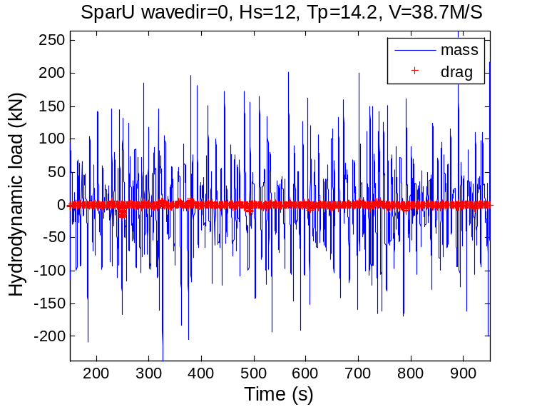
Hydrodynamic force at 2.5m below MWL, blade2seized, V=38.7m/s
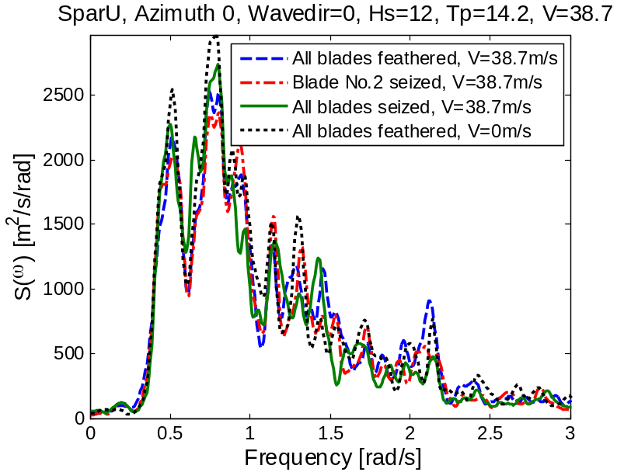
Spectrum of wave force at 2.5m below MWL
Blade azimuth 0, wave direction=0, V=38.7m/s, Hs=12m, Tp=14.2s
Spectrum of wave force at 115m below MWL
Blade azimuth 0, wave direction=0, Hs=12m, Tp=14.2s
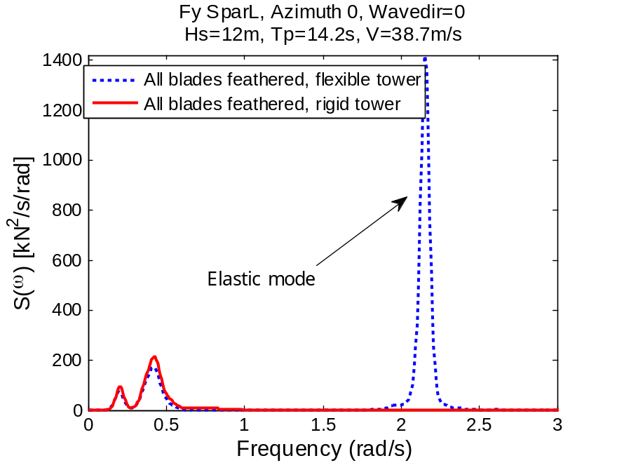
Spectrum of wave force at 115m below MWL
Blade azimuth 0, wave direction=0, V=38.7 m/s, Hs=12m, Tp=14.2s

Environmental condition
The Statfjord site was chosen as a representative site for the wind turbine considered. The environment of the site can be described by a joint probabilistic model proposed by [22]. The marginal distribution of the 1-hour mean wind speed at 10 m was given by

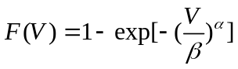
Where α=1.708 and β=8.426. The conditional distribution of Hs for given V was also described by the 2-parameter Weibull distribution with
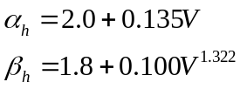
The conditional distribution of Tp can be best fitted by a lognormal distribution
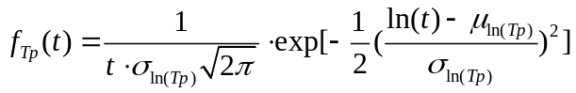
Where the μ_{ln(Tp)} and σ_{ln(Tp)} are the mean value and standard deviation of ln(Tp). They can be expressed as
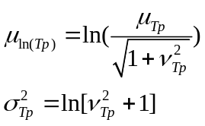
Where μ_{Tp} and σ_{Tp} are calculated by
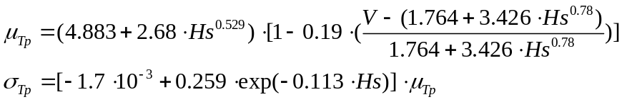
Based on the joint model, a contour surface[23] with a given return period can be obtained:
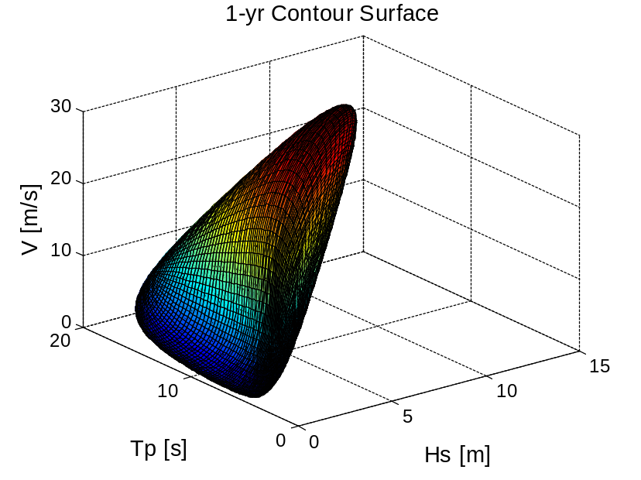
Contour surface of the joint distribution for wind and waves
1 year return period
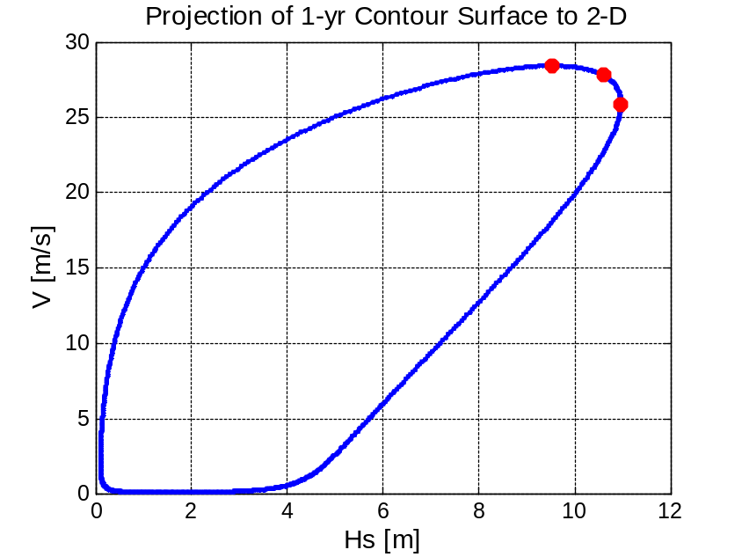
2-D projection of the contour surface of the joint distribution for wind and waves
1 year return period
The physical parameter space (Fig.) yields combinations of the three characteristic parameters with 1-year return period. If there is no inherent variability in the 3-hour extreme values, the expected maximum value of the most unfavorable response among the combinations can be deemed as an estimate for the 1-year extremes [22]. To account for the short-term variability of the responses, artificial inflation of the environmental line or introduction of a higher quantile level can be used[23]. A quantile in the order of 85-90% is usually recommended to predict the 100-year mooring line extreme tensions, but a fitting value for responses of floating wind turbine is not known yet. Generally, the responses are more sensitive to V and Hs than to Tp. To save computational cost, we selected V and Hs based on the 2-D contour surface projection shown in Fig. , and calculated the expected values of Tp.

CASE STUDY

Description of a catenary moored spar wind turbine
Fig. Schematic layout of the spar-type floating wind turbine

The lay-out of the catenary moored spar wind turbine is sketched in Fig.. It consists of a NREL 5 MW turbine, a spar platform and three sets of mooring lines. Main properties are listed in Table 1. The coordinate system marked in red is adopted. Natural period of the system is calculated and listed in Table2. Note that liberalized mooring stiffness at the original position of the platform is used.
Table1 Properties of the spar-type wind turbine
Turbine | NREL 5MW
Water depth (m) | 320
Draft (m) | 120
Displacement (m³) | 8016
Diameter MWL (m) | 6.5
Diameter at bottom (m) | 9.4
Mass (t) | 8216
Centre of gravity (m) | -78.5
Mass (t) | 8216
Mass moment of inertia, Ixx and Iyy (t∙m²) | 6.98∙10⁷
Mass moment of inertia, Izz (t∙m²) | 1.68∙10⁴
Fairlead elevation (m) | 70

Table 2 Natural frequencies of the wind turbine

Motion | Natural period (s) | Natural frequency (rad/s)
Surge | 115 | 0.055
Sway | 125 | 0.05
Heave | 31.4 | 0.2
Roll/pitch | 32.7 | 0.19
Yaw | 7.6 | 0.838

Load cases
A series of design load cases are selected. Three 1-year and one 50-year environmental conditions from the contour line are considered. The red dots in Fig. are the chosen combination of V and Hs with 1-year recurrence; while Tp is calculated by Eq.(). One environment condition is chosen from the 50-year contour surface. The wind speed is extrapolated to the nacelle height using a power law of 0.14 and a 10% increase is applied to scale the 1-hour average wind speed to a 10-min average wind speed[16]. One hour simulation is carried out.
In the parked cases without fault, the blades are all feathered and kept parallel to the wind direction (Fig.2). In the parked cases with pitch mechanism fault, two fault scenarios are investigated. 1) Blade No. 2 is seized and flat to the wind. Blade No.1 and No.3 are normal and parallel to the wind direction. 2) All of the blades are seized and flat to the wind. Moreover, three different blade azimuth positions with azimuth angle γ₁=0, 30 and 60 deg are investigated (Fig.). Different wave misalignment γ₂=0, 45 and 90 deg are also considered (Fig.). Since the yaw mechanism is assumed to be functioning, wind direction is kept constant.
There are four categories as shown in Table 3. Sea state A, B and C correspond to the 1-year environmental condition. Case D corresponds to the 50-year condition. In the column of fault type, 0 refers to the normal parked cases with blades feathered; 1 and 3 corresponds to the cases with one blade (blade 2) and three blades seized respectively.

Table3 load cases for parked conditions
Sea state | V (m/s) | Hs (m) | Tp (s) | I | Blade azimuth γ₁ (deg) | Misalignment γ₂ (deg) | Fault type
A (1-yr) | 38.7 | 11.0 | 14.2 | 0.12 | 0, 30, 60 | 0, 45, 90 | 0,1,3
B (1-yr) | 42.5 | 9.5 | 12.9 | 0.12 | 0, 30, 60 | 0, 45, 90 | 0,1,3
C (1-yr) | 41.6 | 10.6 | 13.7 | 0.12 | 0, 30, 60 | 0, 45, 90 | 0,1,3
D (50-yr) | 49.4 | 14.3 | 15.4 | 0.10 | 0, 30, 60 | 0, 45, 90 | 0

Results and discussions

Effect of blade azimuth position and wave misalignment
When the rotor is brought to standstill, blade1 would assume an azimuth angle γ₁. Azimuth position would affect the aerodynamic loading and thus the responses due to wind shear and blade symmetry. Platform surge motion and pitch motion are less affected by the blade azimuth position for either type of fault. Roll motion and yaw motion are most affected by azimuth with fault type 0 and fault type 1. Tower bottom bending moment and shear force are generally less sensitive to the azimuth.
For a given environmental condition and wave misalignment, when the turbine is normal feathered (fault type 0), the wind-induced yaw responses are affected by the change of blade loads (Fig.) When γ₂=0, there are two blades in the upper half of the azimuthal circle, leading to heavier loads on blade 2 and blade 3. For sea state A, γ₂=0 deg, maximum yaw angle at γ₁=0 deg is 6.13 deg, 127.8% larger than that at γ₁=60 deg. Roll motion is slightly affected.
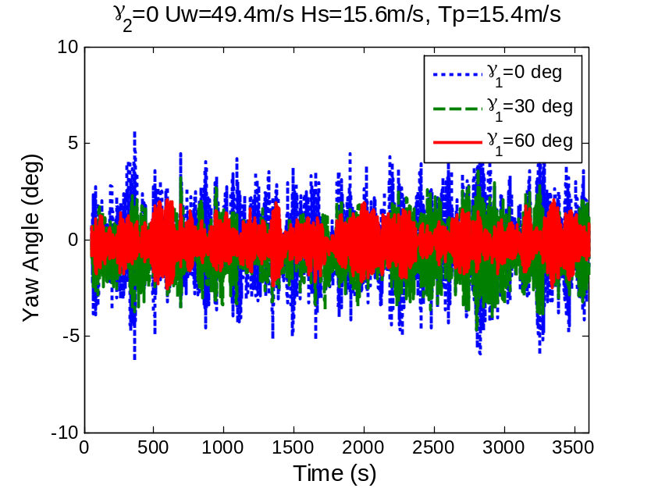
Normal parked condition, wave misalignment=0 deg, V=49.4 m/s, Hs=15.6m, Tp=15.4s
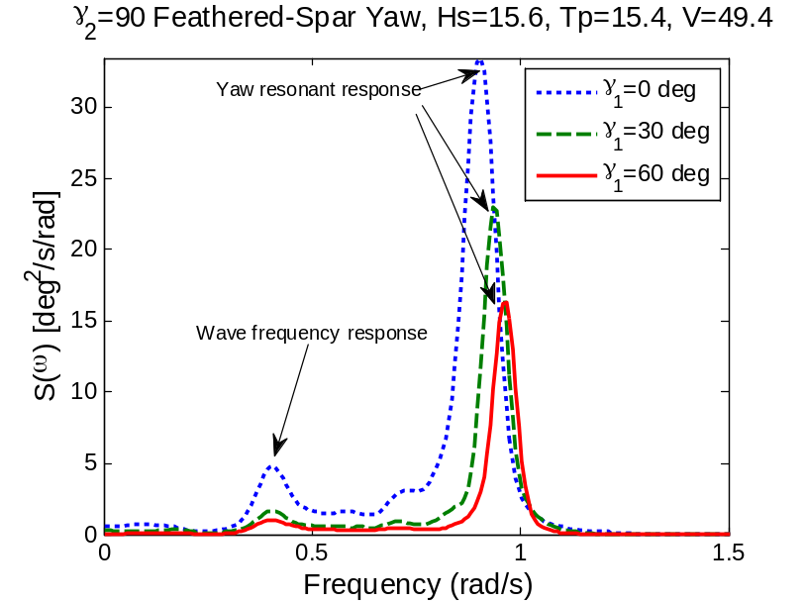
Normal parked condition, wave misalignment=90 deg, V=49.4 m/s, Hs=15.6m, Tp=15.4s
When only blade 2 is seized (fault type 1), a difference in the blade azimuth would create a more uneven distribution of wind loads than with fault type 3. γ₂=60 deg leads to less roll maximum values as well as standard variations. This observation also holds in most of the conditions for the yaw motion due to the special symmetry of the blades. At sea state 2, wave misalignment 0 deg, the minimum yaw angle experienced by γ₁=0 deg is -11.4 deg; while γ₁=60 deg results in a minimum yaw angle of -2.47 deg only (Fig.) .
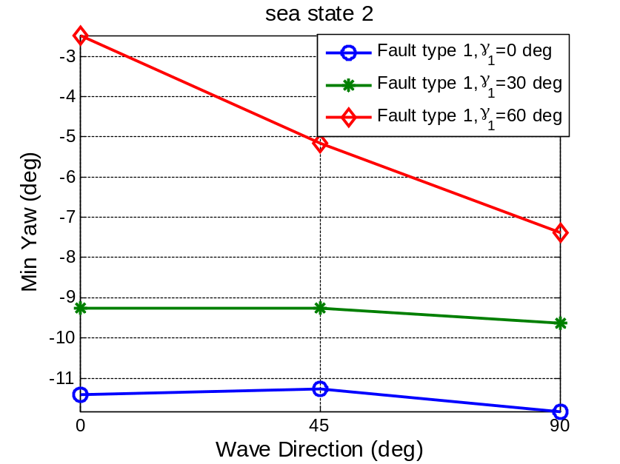
Min yaw value, fault type 1, sea state2
Wave misalignment plays a big role in affecting the responses. This can be found in Table. Three 1-year sea states are considered. All of the responses except yaw motion have consistent wave misalignment when extreme values occur.

Table, extreme values and corresponding pramaters, sea state A-C

 | Extrem Value | Blade Azimuth γ1 (deg) | Wave direction γ2 (deg) | Sea State | Fault type
Surge (m) | 77.2 | 30 | 0 | 2 | 3
Sway (m) | -26.2 | 30 | 90 | 2 | 0
Roll (deg) | 6.58 | 30 | 90 | 2 | 1
Pitch (deg) | 15.3 | 30 | 0 | 2 | 3
Yaw (deg) | -11.9 | 0 | 0 | 3 | 2
Tower shear Fy (kN) | 3573.9 | 0 | 0 | 2 | 3
Tower moment My (kNm) | 214933 | 0 | 90 | 2 | 2
Flapwise bending moment of blade1 (kNm) | 12698.2 | 0 | 90 | 3 | 2

Comparison between normal and fault conditions

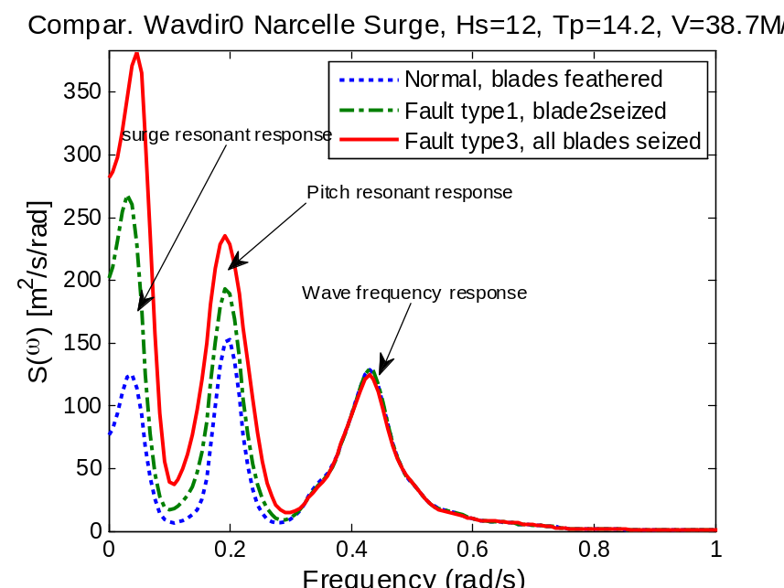
Nacelle surge spectrum, blade azimuth 0, V=38.7m/s, Hs=12m, Tp=14.2s

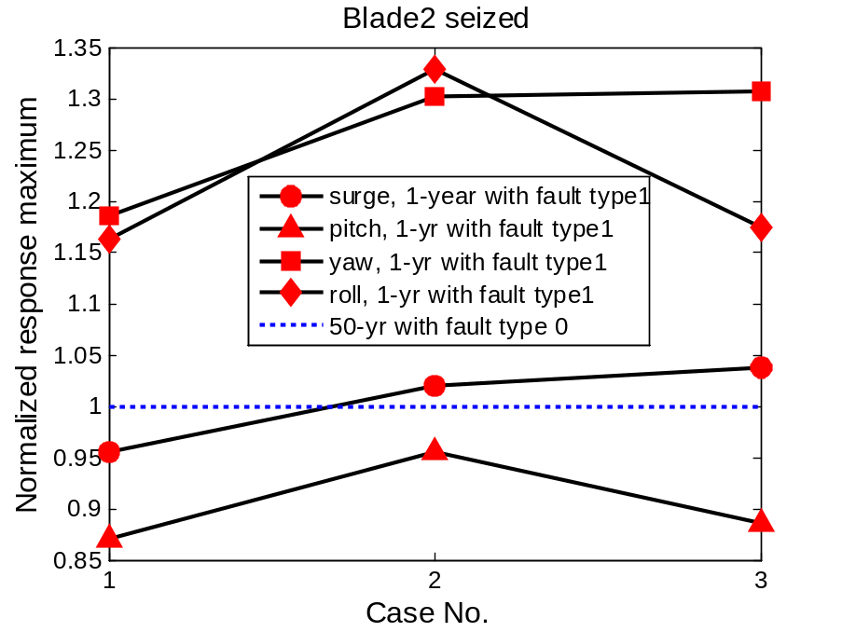
Comparison between fault and normal cases for the 1-year environment
The normalized values of responses: (sea states A-C, values of blade2seized/feathered)

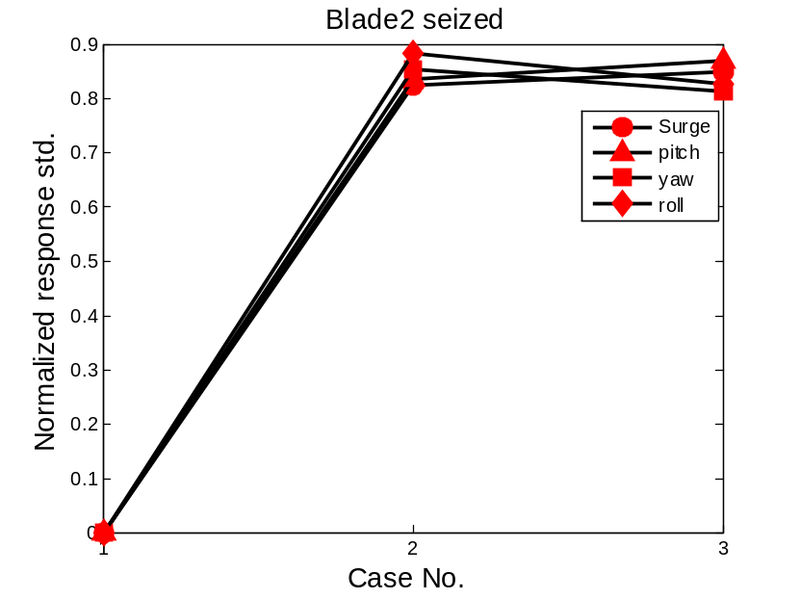
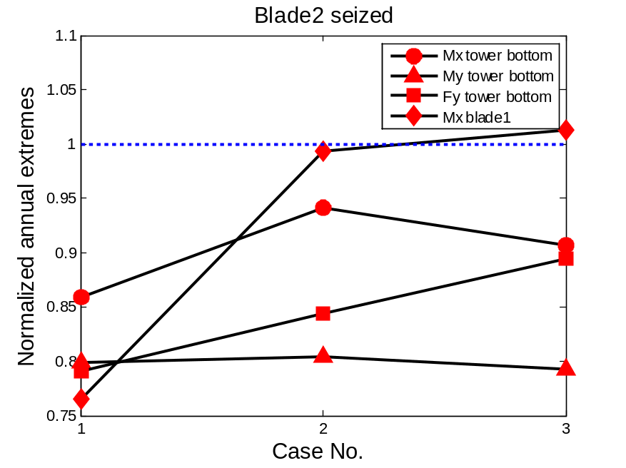

Extreme Values

[1] Burton T, Jenkins N, Sharpe D, Bossanyi E. Wind Energy Handbook: Wiley Online Library; 2011.
[2] Twidell J, Gaudiosi G. Offshore Wind Power. Wind Engineering. 2010;34:123-4.
[3] Comission IE. IEC 61400-3 Ed.3. Wind Turbines. Part3: Design Requirements for offshore wind turbines. Geneva2009.
[4] DNV. DNV-OS-J101 Design of Offshore Wind Turbine Structures. 2010.
[5] Arabian-Hoseynabadi H, Oraee H, Tavner P. Failure Modes and Effects Analysis (FMEA) for wind turbines. International Journal of Electrical Power & Energy Systems. 2010;32:817-24.
[6] Ribrant J. Reliability performance and maintenance-a survey of failures in wind power systems.
[7] Michael Wilkinson BH. Deliverable 1.3: Report on Wind Turbine Reliability Profiles. GL Garrad Hassan; 2011.
[8] Tavner P. Recommendations from the ReliaWind Consortium for the Standardisation for the Wind Industry of Wind Turbine Reliability Taxonomy, Terminology and Data Collection. Durham University; 2011.
[9] Thomas Esbensen CS. Fault Diagnosis and Fault-Tolerant Control of Wind Turbines: Aalborg University; 2009.
[10] DNV/Risø. Guidelines for Design of Wind Turbines. 2002.
[11] Bir G, Jonkman J. Aeroelastic instabilities of large offshore and onshore wind turbines. IOP Publishing; 2007. p. 012069.
[12] Jonkman J, Buhl Jr M. Loads Analysis of a Floating Offshore Wind Turbine Using Fully Coupled Simulation. 2007.
[13] Matha D. Model Development and Loads Analysis of an Offshore Wind Turbine on a Tension Leg Platform with a Comparison to Other Floating Turbine Concepts: April 2009. National Renewable Energy Laboratory (NREL), Golden, CO.; 2010.
[14] Karimirad M, Moan T. Effect of Aerodynamic and Hydrodynamic Damping on Dynamic Response of Spar Type Floating Wind Turbine. European Wind Energy Conference2010. p. 55.
[15] Laboratory RN. How 2 HAWC2, The User's Manual. Technical University of Denmark; 2009.
[16] Karimirad M, Moan T. Wave and Wind Induced Dynamic Response of a Spar‐Type Offshore Wind Turbine. Journal of Waterway, Port, Coastal, and Ocean Engineering. 2011;1:55.
[17] Karimirad M, Meissonnier Q, Gao Z, Moan T. Hydroelastic code-to-code comparison for a tension leg spar-type floating wind turbine. Marine Structures. 2011.
[18] Hansen MOL. Aerodynamics of wind turbines: Earthscan/James & James; 2008.
[19] Hansen MH. Aeroelastic instability problems for wind turbines. Wind Energy. 2007;10:551-77.
[20] Holmes JD. Wind loading of structures: Taylor & Francis Group; 2007.
[21] Faltinsen OM. Sea loads on ships and offshore structures: Cambridge Univ Pr; 1993.
[22] Johannessen K, Meling T, Haver S. Joint distribution for wind and waves in the northern north sea. 2001.
[23] Haver SK. Prediction of Characteristic Response for Design Purposes (PRELIMINARY VERSION). Statoil; 2011.

